Objectives:

* To describe Java coordinate systems in a GUI component
* To draw things using the methods in the **Graphics** class
* To override the **paintComponent** method to draw things on a GUI component
* To use a panel as a canvas to draw things
* To draw strings, lines, rectangles, ovals, arcs, and polygons

**There are two challenge exercises, each worth 50%**

If you need paintComponent to execute (i.e., if you want to update the graphics drawn on a Swing component), you can call method **repaint**, which is inherited by all JComponents indirectly from class Component (package java.awt). The header for repaint is

|  |
| --- |
| public void repaint() |

In order to draw things on a component, you need to define a class that extends **JPanel** and overrides its **paintComponent** method to specify what to draw.

The **paintComponent** method is automatically invoked to paint graphics when the component is first displayed or whenever the component needs to be redisplayed.

Invoking **super.paintComponent(g)** invokes the **paintComponent** method defined in the superclass. This is necessary to ensure that the viewing area is cleared before a new drawing is displayed. Invokes the **drawLine** method to draw a line from (**0**, **0**) to (**50**, **50**). Invokes the **drawString** method to draw a string.

Example #1

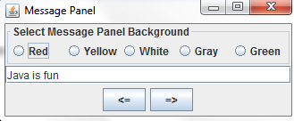

Create a new class and name it Ex1 using either net beans or eclipse

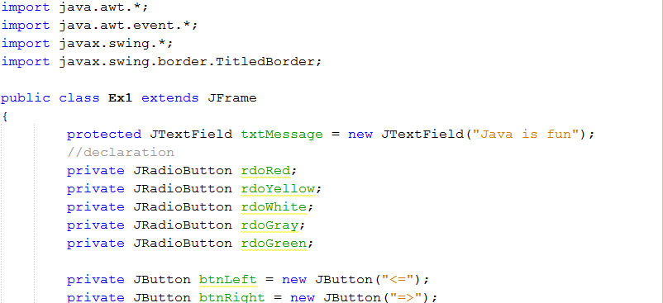

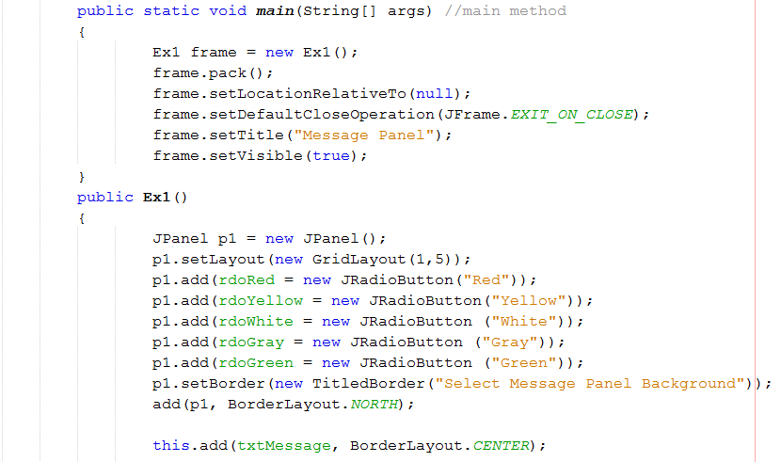

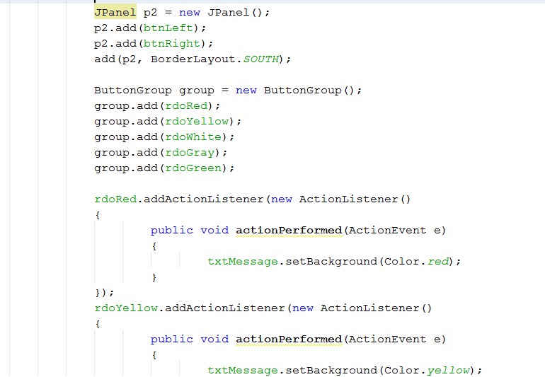

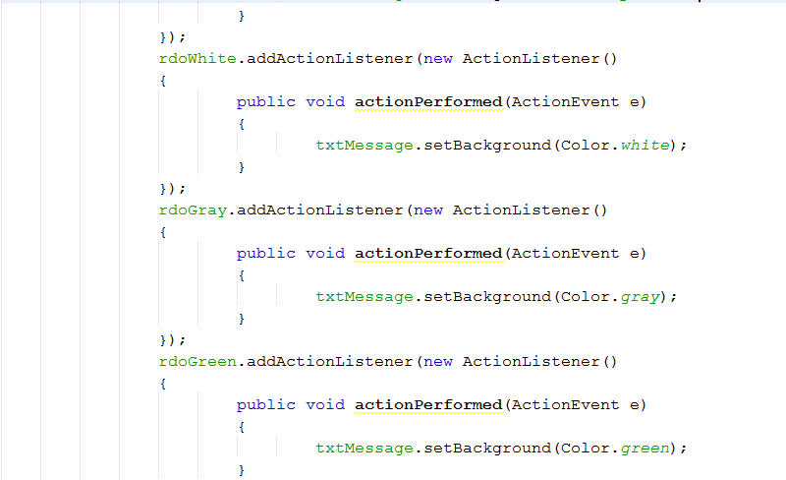

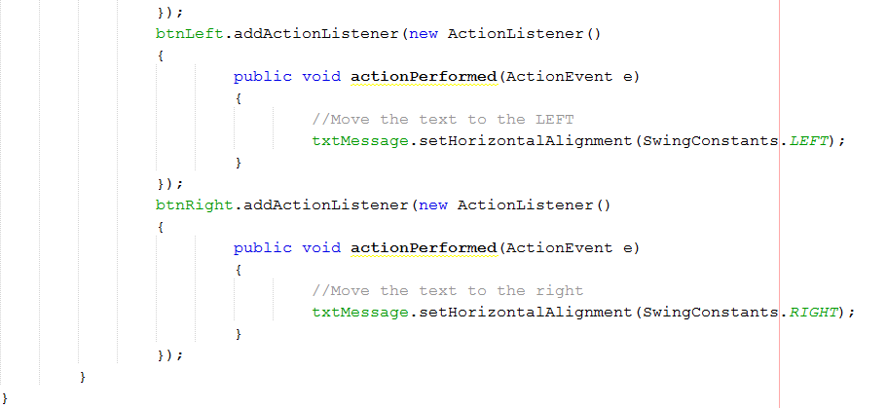

Example #2:

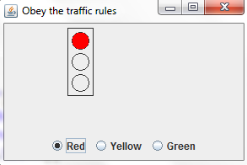

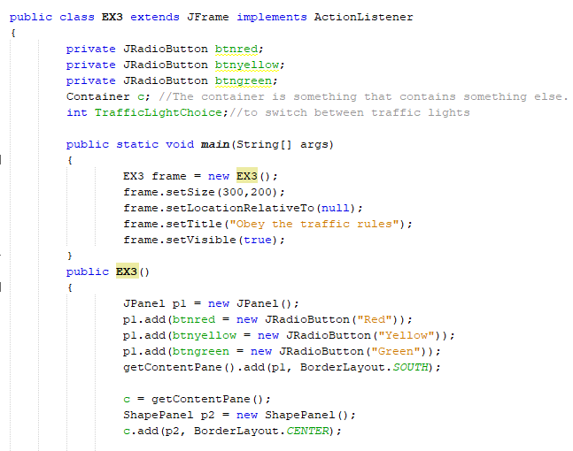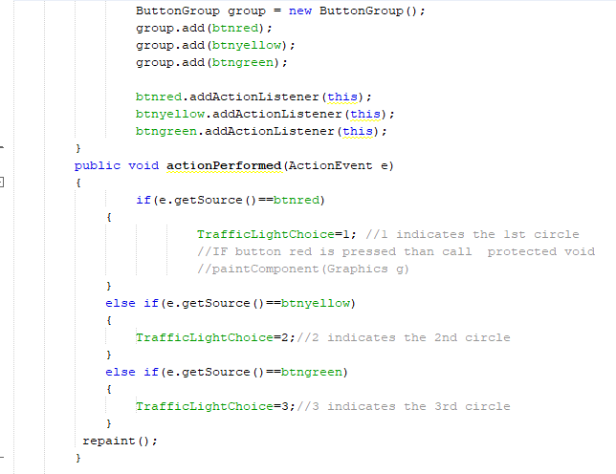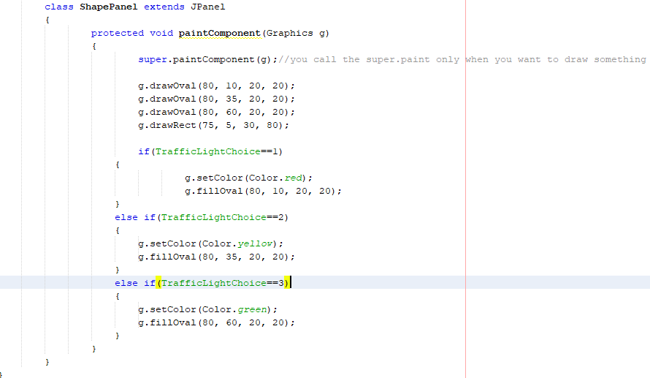

Example #3:

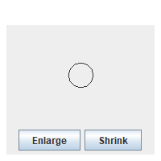

Code on next page…

Code: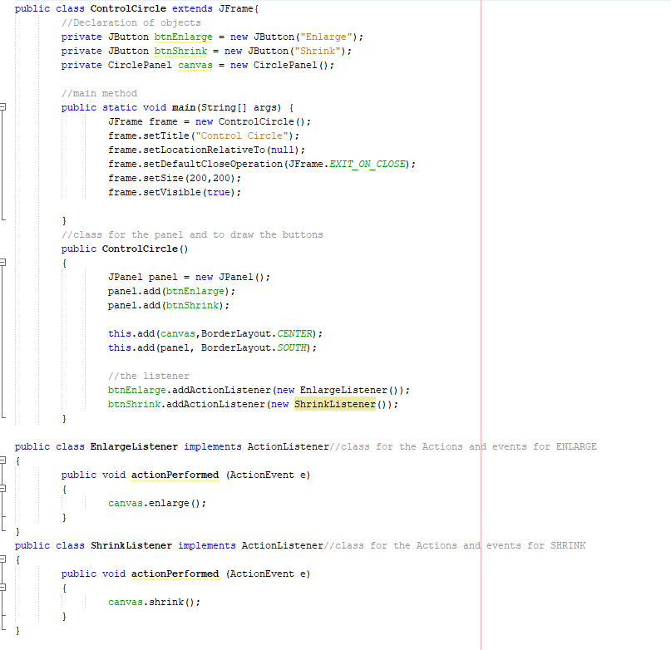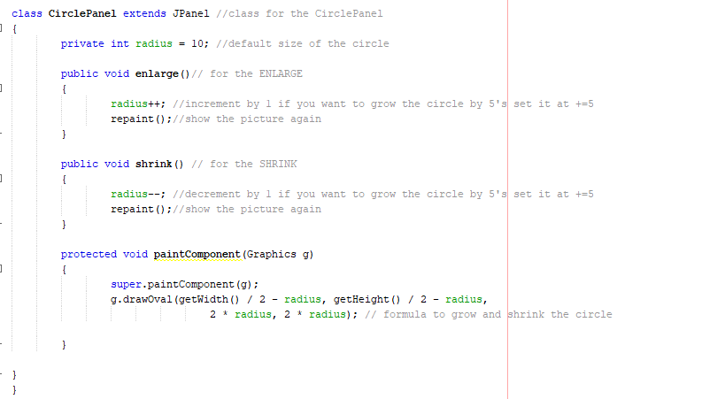

Using a JFrame to play music (Download the **windows.wav** file from Module 5)

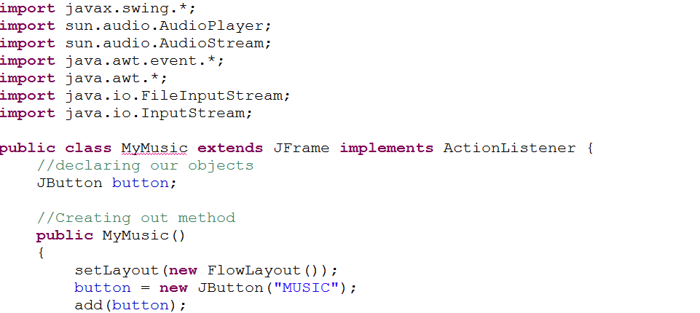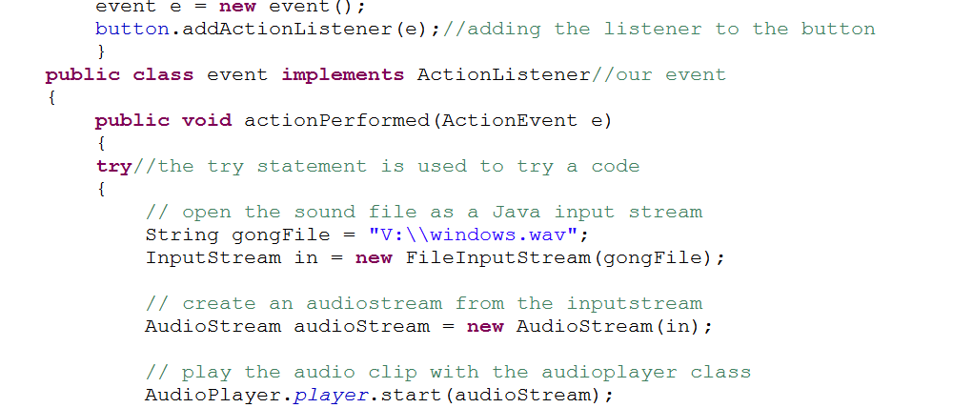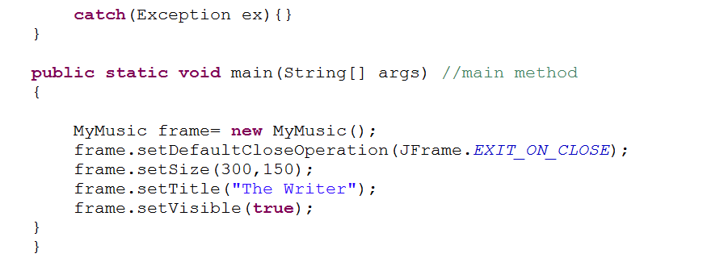

**Challenge Exercise #1**

Using a JFrame complete the (Retail Calculator) program below.

**#1 Print screen the running application with the code below here**

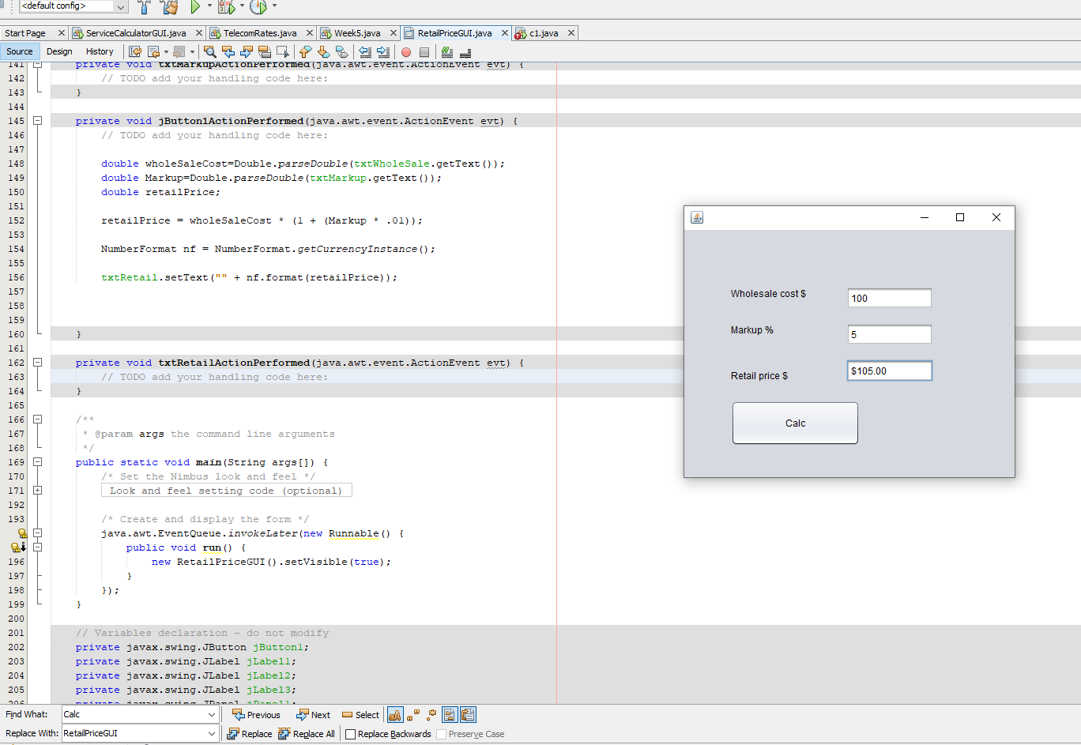

**Challenge Exercise #2**

Using a JFrame complete the (MPG) program below.

**#2 Print screen the running application with the code below here**

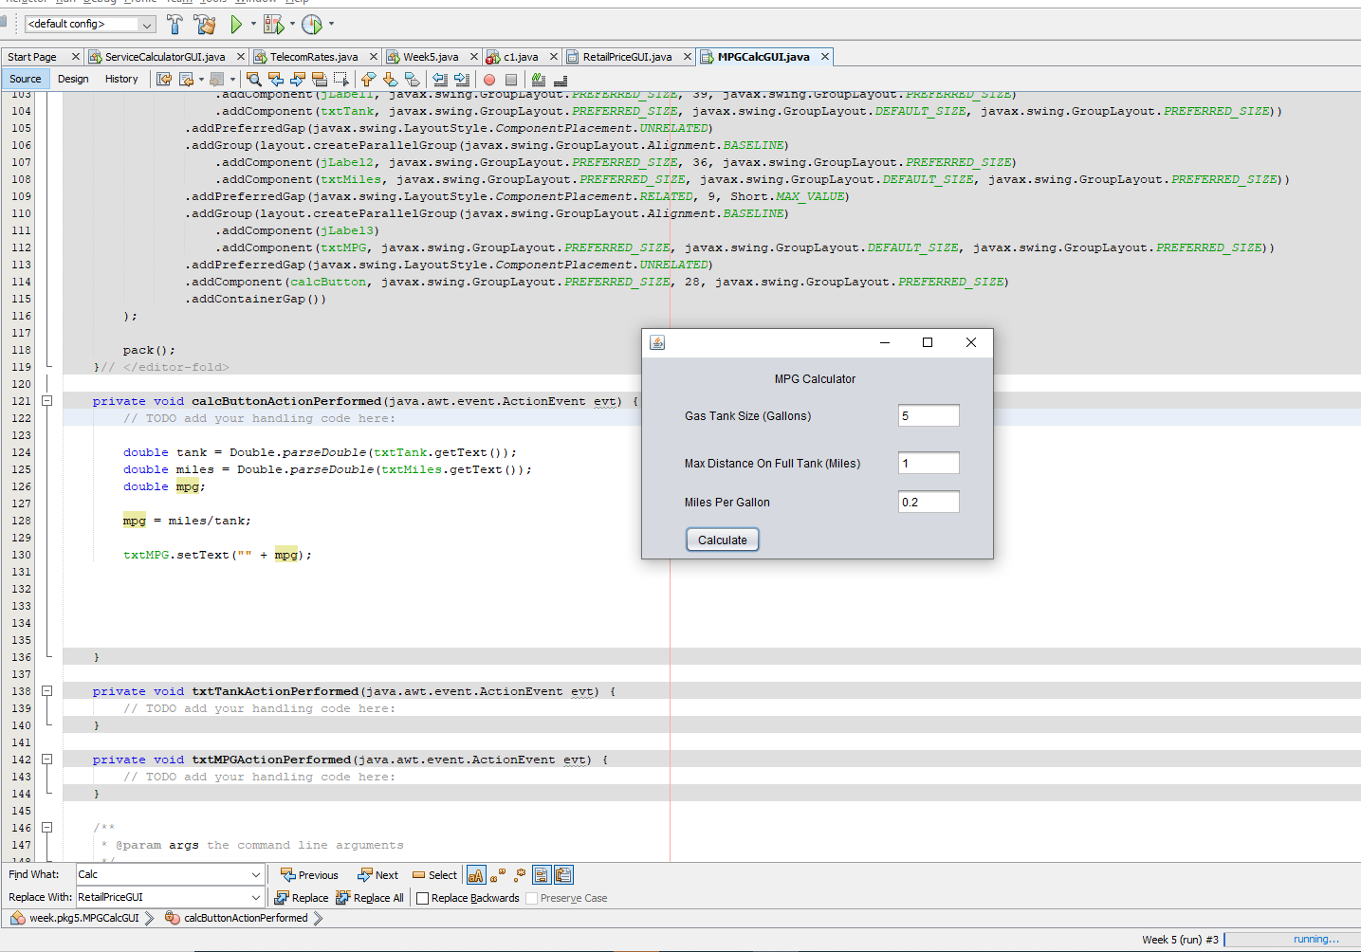

**Submit this document to Module 5 Class Exercise**